Name: ____________________________________ Student ID: _________________

BN3402 Bioanalytics for Engineers
Training Module - Microscopy
Maximum Score: 9 points

Goal:
In this assignment, you are to observe the different organelles and proteins and determine the organelles/proteins as seen in Sample 1, 2, and 3 according to the colour it has been stained using fluorescence microscopy.
Learning Objectives:
1) Use StarCellBio to perform fluorescence microscopy experiments
2) Analyse fluorescence microscopy images to identify different organelles and proteins
Background Introduction:
Microscopy is a technique that allows us to view samples that cannot be seen with the naked eye. By selectively labelling proteins, structures, and biological processes with fluorescent proteins, what you can observe and track increases dramatically. In this assignment, you are provided with the microscopy images of different organelles respectively and you are to determine the organelles and/or proteins as seen in Sample 1, 2, and 3 according to the colour it has been stained.
Question 1:
What are the organelles and/or proteins in Sample 1 that are labelled in blue, green, and red respectively?
Blue: Nucleus
Green: Plasma Membrane
Red: Cytoplasm

Question 2:
What are the organelles and/or proteins in Sample 2 that are labelled in blue, green, and orange respectively?
Blue: Endoplasmic Reticulum
Green: Tubulin
Orange: Actin

Question 3:
What are the organelles and/or proteins in Sample 3 that are labelled in red, green, and orange respectively?
Red: Mitochondria
Green: Golgi Apparatus
Orange: Lysosome

Microscopy Images:
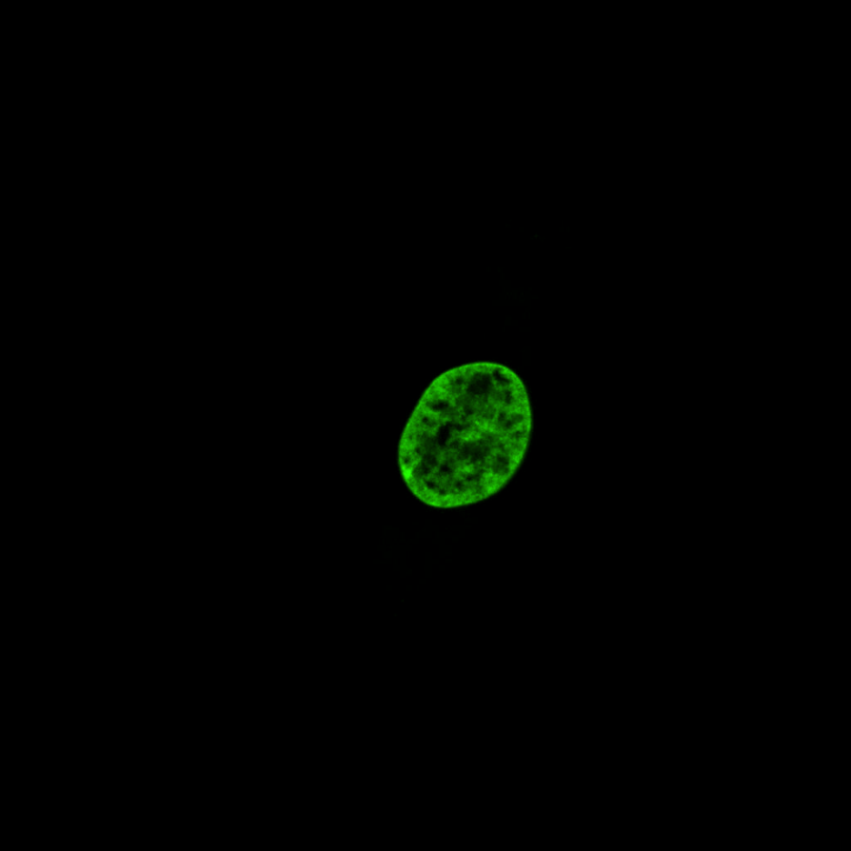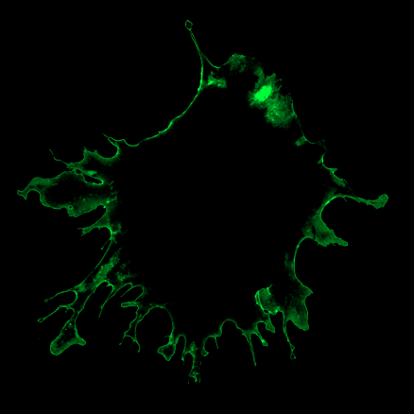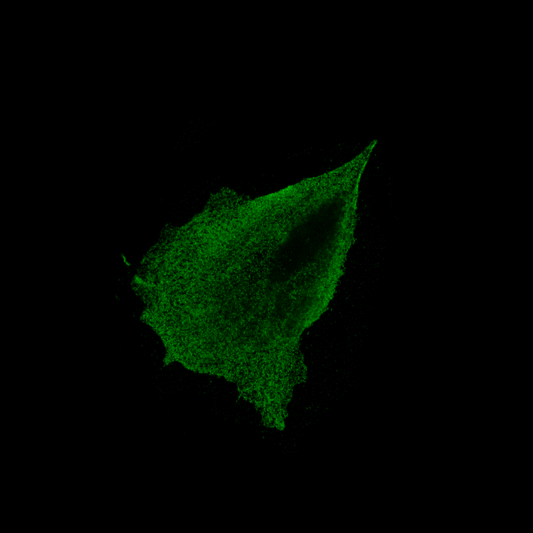
Nucleus Plasma Membrane Endoplasmic Reticulum
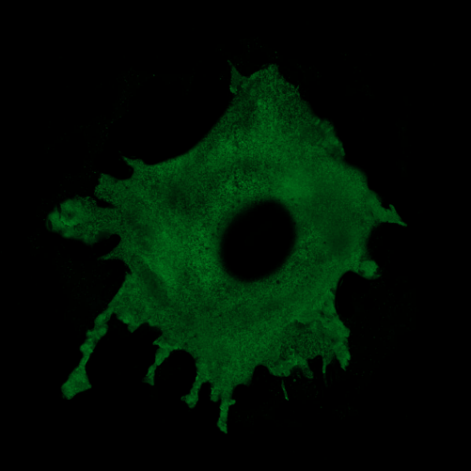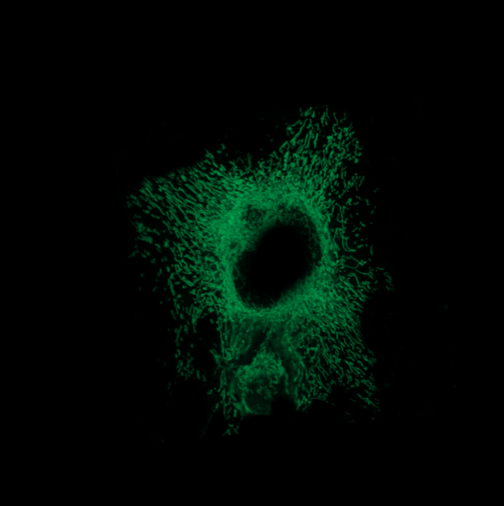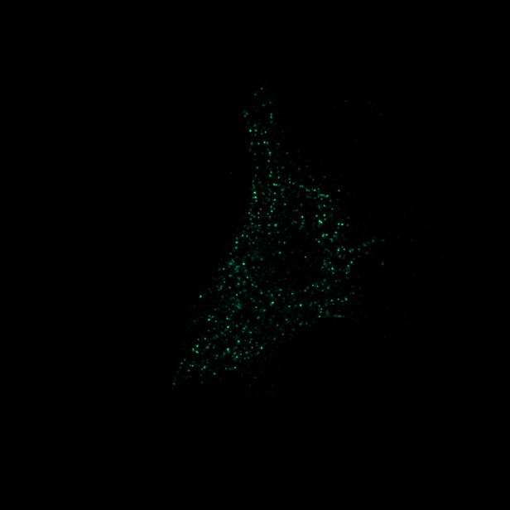
Cytoplasm Mitochondria Lysosome
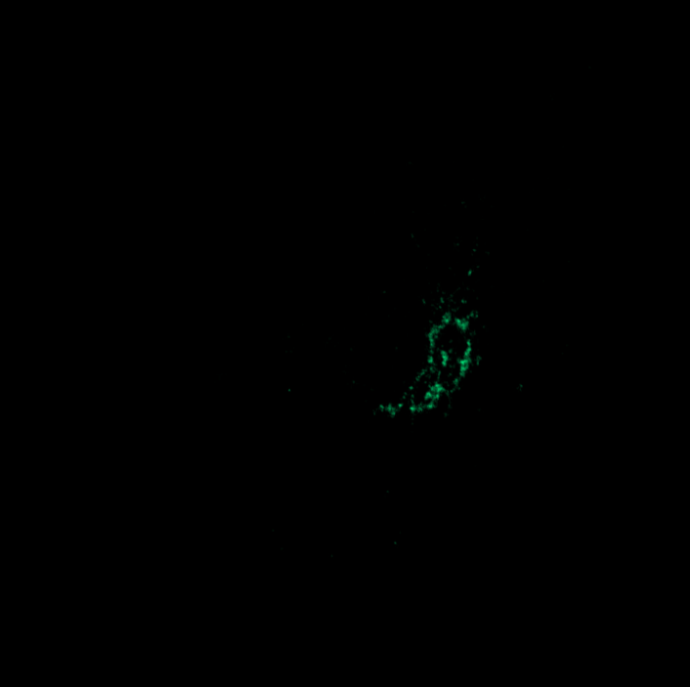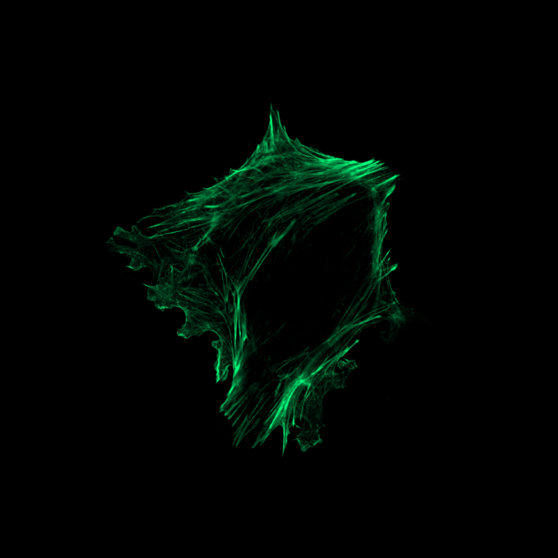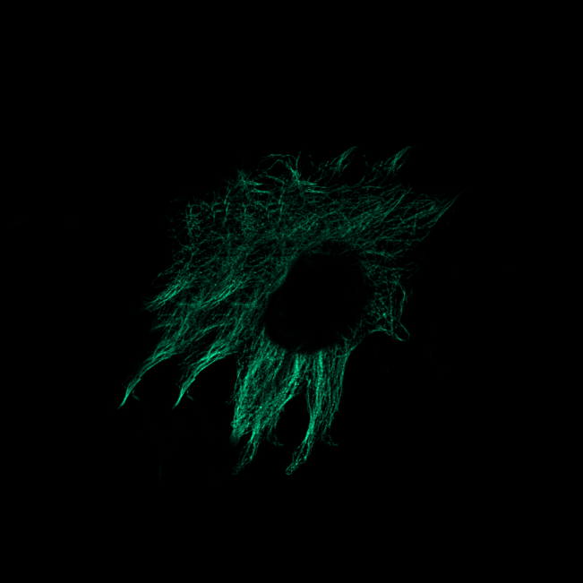
Golgi Apparatus Actin Tubulin
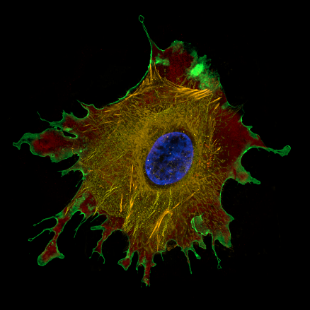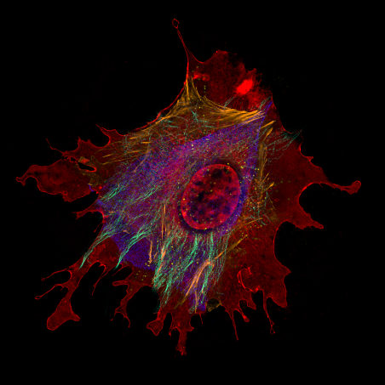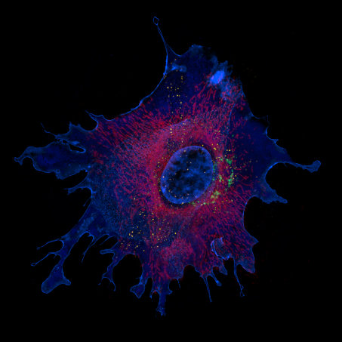
Sample 1 Sample 2 Sample 3

